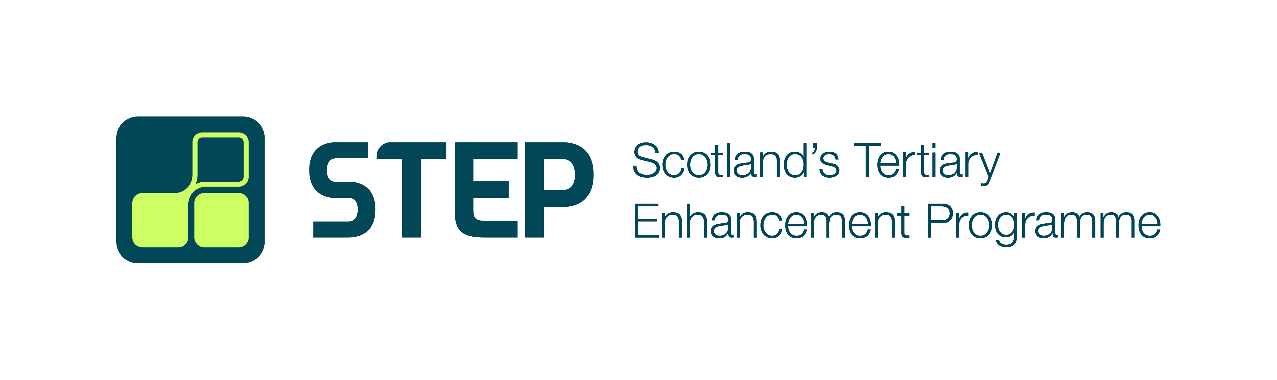

Call for STEP Project Proposals
Proposals invited for projects relating to student support
QAA and CDN, on behalf of the STEP Steering Group, are pleased to open a call for proposals for a STEP project to run during session 2025-26. Up to £10,000 is available for a project on the topic of Delivering Tailored, Targeted and Personalised Support. Project proposals should be submitted to info@step.ac.uk by Wednesday, 3 December 2025 for consideration.
STEP (Scotland’s Tertiary Enhancement Programme) is the national enhancement programme for the Scottish tertiary sector. It is designed to enable Scotland’s colleges and universities to work together to improve and enhance learning, teaching, the student experience, and staff development across tertiary provision.
STEP is one of the delivery mechanisms of Scotland’s Tertiary Quality Enhancement Framework (TQEF) and is underpinned by the TQEF principles. At the heart of the programme are collaborative enhancement projects that will produce outcomes and outputs of value to the entire tertiary sector.
The topic for the first cycle of STEP (2024-2028), determined through extensive engagement with colleges and universities, is Supporting Diverse Learner Journeys. There are four priority areas:
- Supporting Transitions and Exploring Pathways
- Strengthening Engagement, Community and Belonging
- Developing Skills and Capabilities for Learning
- Delivering Tailored, Targeted and Personalised Support.
In order to ensure that all four of these priority areas are addressed, we are now inviting proposals for work on Delivering Tailored, Targeted and Personalised Support. This might relate to:
- Support for a specific cohort, or students with a specific characteristic or experience (though please note that we are already supporting a project relating to disability)
- Support for a specific aspect of the student experience
- Student peer support
- Support relating to health and wellbeing.

Who can apply
This call is open to all staff and students at Scottish colleges and universities. You do not have to be involved with STEP to apply, though we would encourage you to speak to your institution’s STEP Network members before starting work on an application. If you do not know who your institution’s STEP Network members are, please email us at info@step.ac.uk and we will put you in touch.

Project criteria
- The project will be able to launch in January 2026 and conclude in July 2026
- The project will cost no more than £10,000
- The project will be collaborative - that is, it must involve multiple institutions or agencies
- The project will be tertiary - that is, the project must involve at least one college and at least one university
- The project team will include a student from a college or university
- The project will aim to enhance the quality of learning, teaching, the student experience, and staff development in Scotland.

Application process
Interested parties are invited to submit the attached project proposal form to info@step.ac.uk. To successfully complete this form, a team will need to have considered carefully:
- The strategic case for the project - the context and need
- The project’s scope - its aim and objectives
- The project’s outcomes and indicators of success
- The project’s activities and outputs
- An indicative project timeline
- An indication of how the project will be managed
- The proposed approach to student partnership and engagement
- The proposed approach to dissemination
- An indication of the resources required to deliver the project, using the below table as a guide.
Item | Description | Amount
Student incentives | Payment or incentive for students who are not part of the project team to participate in focus groups or other project activities | £12.60 per hour or equivalent in vouchers
Staff remuneration | For staff (including project team members) undertaking work as part of the project | £45.00 p/hour
Student remuneration | For student interns, or student project team members undertaking work as part of the project | £15.00 p/hour
T&S | For travel and subsistence to attend other project events (e.g. dissemination events, meetings) | £150 per person, per event
Dissemination events | For venue hire and catering for one-day event | £800
Contingency | To cover unexpected costs | 10% of the budget cost

Timeline
- Wednesday 3 December 2025 - deadline for applications
- Wednesday 17 December 2025 - applications to be considered by the STEP Steering Group
- Friday 19 December 2025 - deadline for decisions to be communicated to project teams
- Friday 16 January 2026 - deadline for contract to be issued to lead institution
- Friday 23 January 2026 - deadline for contract to be signed by both parties
- Friday 20 January 2026 - deadline for receipt of detailed project plan, triggering first payment instalment
- Tuesday 30 June 2026 - deadline for all deliverables plus end-of-year report, triggering final payment instalment.

Project Proposal Form 2024-25
This form is intended for completion by teams who wish to apply for up to £10,000 to support a project on the topic of Delivering Tailored, Targeted and Personalised Support, to be concluded by June 2026.
Please return this form to info@step.ac.uk no later than 5pm on Wednesday 3 December 2025.
The STEP Steering Group will consider proposals at its meeting on Wednesday 17 December 2025, after which decisions and feedback will be communicated to project teams.

1. The Project Team
Please use the table below to indicate who will be involved with this project.
Contact details (including name, job title, email and telephone number)
Name of lead institution
While there may be co-leads to help support the delivery of the work, there should be a single lead institution for contracting purposes.
Name(s) of partner institutions
One institution per row (add more rows as necessary).
By adding institutions’ details, you are confirming that they have agreed to be part of the project. Please note that you can include additional institutions as the project proceeds, but you need at least one partner to begin. Each project must have at least one HEI and one college as partners.

2. The Strategic Case
Please use the tables below to provide more detail about your project.
2.1 Title
This should communicate the key essence of the project without being overly long or wordy.

2.2 Context and rationale for project
This section should set out the background and need for the project. You should consider:
- What is the current context in this area?
- What needs to be achieved? What changes need to be implemented?
- How will the proposed project achieve impactful change in this area?
You may wish to include references to publications, case studies, statistics, etc. here appropriate. Maximum 500 words.

2.3 Project scope
Identify the high-level aims and the objectives of the project. You must demonstrate that the project’s aim and objectives clearly align with the priority area Delivering Tailored, Targeted and Personalised Support.
Aim: Using a few sentences, explore what the project will aim to achieve.
Objectives: Set out your objectives that demonstrate how the aim will be achieved using bullet points. Provide a few sentences for each objective, demonstrating its relevance supporting the achievement of the project aim.

2.4 Outcomes and indicators of success
State the intended outcomes of the project and how these will be demonstrated, referring to specific metrics. This section should make clear how the project will impact on both the participating institutions and the Scottish tertiary sector more broadly. Maximum 500 words.
Short term (one year)
Medium term (two to three years)
Long term (over three years)

3. Project planning
Please use the tables below to provide more detail about your project, the planned project outputs (things undertaken/produced) and your plans to manage the project outcomes (results of activities and things produced) to specification.
3.1 Activities and outputs
Identify the key activities and outputs that your project will deliver, and how these will build on previous sector work and outputs (where relevant). Maximum 500 words.

3.2 Timeline
Provide an indicative timeline here illustrating the key phases of the project. Please consider activities that may need longer lead-in times, such as recruitment of project staff and ethical approval for research activity.
A detailed project plan with SMART objectives will be required if the project is approved.

3.3 Project management
State how the project will be managed by the delivery team, providing information on individual and institutional responsibilities for accountability. Detail anticipated time required for teams to undertake activities, participate in meetings, attend events, etc., within and across institutions. Outline how risks will be identified and mitigated. Maximum 500 words.

3.4 Student engagement and partnership
Indicate how you will engage with students throughout your project. You should refer to the eight features of Scotland’s Ambition for Student Partnership. Maximum 500 words.
Surveying students
If you intend to survey students as part of your project, please indicate which students you hope to reach and when.

3.5 Dissemination
Please indicate how you will engage with the sector more widely and take steps to disseminate and embed the work of your project. This might include partner and wider sector meetings and consultation, and the publication and promotion of your outputs. Maximum 500 words.

3.6 Resources required to deliver the project
Provide a breakdown of funding and other support you would require in each year of the project. If you are planning a one-year project, please delete any unnecessary rows. Please note that funding will be confirmed on an annual basis.
Please refer to the project costings table for guidance when completing this section.

